# 

### Semester One Examination, 2016

### Question/Answer Booklet

# MATHEMATICS

**SOLUTIONS**

**METHODS**

**UNIT 1**

## Section Two:

## Calculator-assumed

|  |  |  |  |  |  |  |  |  |
| --- | --- | --- | --- | --- | --- | --- | --- | --- |
| Student Number: In figures |  |  |  |  |  |  |  |  |

In words

Your name

## Time allowed for this section

Reading time before commencing work: ten minutes

Working time for section: one hundred minutes

## Materials required/recommended for this section

***To be provided by the supervisor***

This Question/Answer Booklet

Formula Sheet (retained from Section One)

***To be provided by the candidate***

Standard items: pens (blue/black preferred), pencils (including coloured), sharpener, correction fluid/tape, eraser, ruler, highlighters

Special items: drawing instruments, templates, notes on two unfolded sheets of A4 paper, and up to three calculators approved for use in the WACE examinations

## Important note to candidates

No other items may be taken into the examination room. It is **your** responsibility to ensure that you do not have any unauthorised notes or other items of a non-personal nature in the examination room. If you have any unauthorised material with you, hand it to the supervisor **before** reading any further.

## Structure of this paper

|  |  |  |  |  |  |
| --- | --- | --- | --- | --- | --- |
| Section | Number of questions available | Number of questions to be answered | Working  time (minutes) | Marks available | Percentage of exam |
| Section One:  Calculator-free | 7 | 7 | 50 | 51 | 35 |
| Section Two:  Calculator-assumed | 13 | 13 | 100 | 98 | 65 |
|  | | | **Total** | 149 | 100 |

## Instructions to candidates

1. The rules for the conduct of examinations are detailed in the school handbook. Sitting this examination implies that you agree to abide by these rules.
2. Write your answers in this Question/Answer Booklet.
3. You must be careful to confine your response to the specific question asked and to follow any instructions that are specified to a particular question.
4. Spare pages are included at the end of this booklet. They can be used for planning your responses and/or as additional space if required to continue an answer.

* Planning: If you use the spare pages for planning, indicate this clearly at the top of the page.
* Continuing an answer: If you need to use the space to continue an answer, indicate in the original answer space where the answer is continued, i.e. give the page number. Fill in the number of the question that you are continuing to answer at the top of the page.

1. **Show all your working clearly**. Your working should be in sufficient detail to allow your answers to be checked readily and for marks to be awarded for reasoning. Incorrect answers given without supporting reasoning cannot be allocated any marks. For any question or part question worth more than two marks, valid working or justification is required to receive full marks. If you repeat any question, ensure that you cancel the answer you do not wish to have marked.
2. It is recommended that you **do not use pencil**, except in diagrams.
3. The Formula Sheet is **not** to be handed in with your Question/Answer Booklet.

Section Two: Calculator-assumed 65% (99 Marks)

This section has**thirteen (****13)** questions. Answer **all** questions. Write your answers in the spaces provided.

Working time for this section is 100 minutes.

Question 8 (6 marks)

(a) Show how to establish that the exact value of  is . (3 marks)

|  |
| --- |
| **Solution** |
| From diagram, it can be seen that .  Using , . |
| **Specific behaviours** |
| ✓ sketches isosceles triangle with angle and sides shown  ✓ uses triangle to obtain cos45  ✓ uses unit circle identity to obtain cos135 |

(b) The graphs of  and  are shown below. Determine, to the nearest degree, the size of the angle . (3 marks)

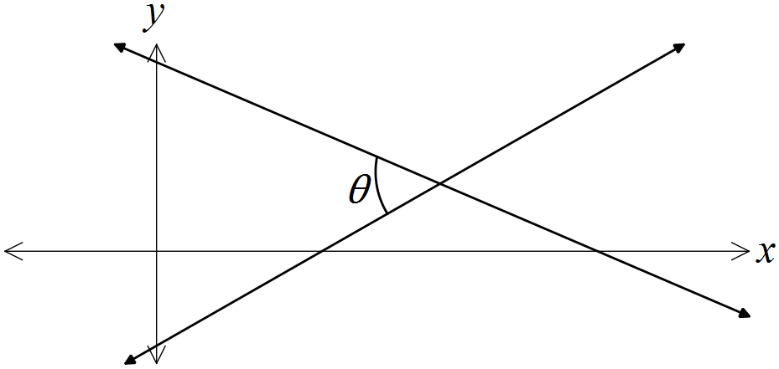

|  |
| --- |
| **Solution** |
|  |
| **Specific behaviours** |
| ✓ determines both gradients  ✓ calculates angle of lines to x-axis  ✓ determines required angle |

Question 9 (7 marks)

The graphs of the functions,  and  are shown below, where a, b, c, d, m and n are positive constants.

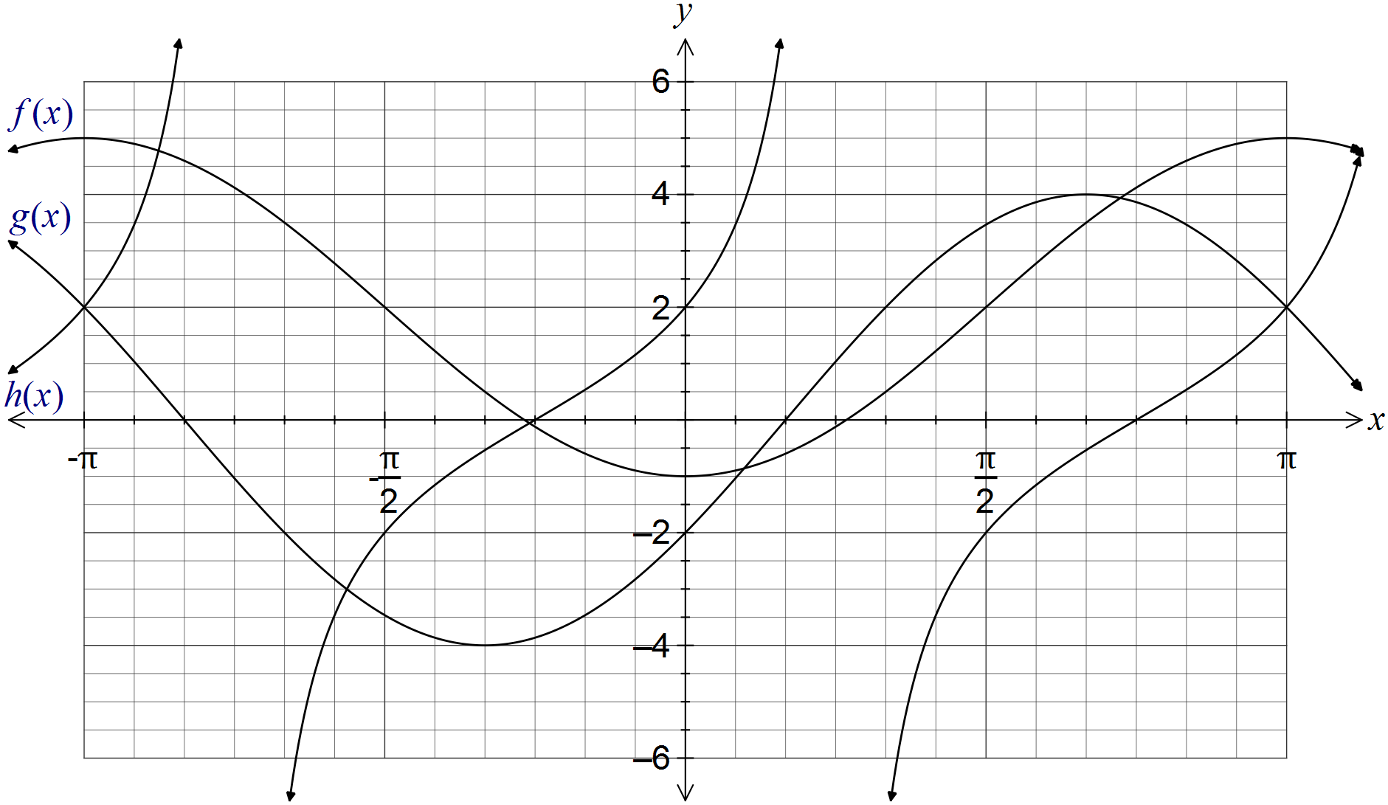

(a) Clearly label each of the functions f, g and h on the graph. (1 mark)

(b) Determine the values of the positive constants a, b, c, d, m and n. (6 marks)

|  |
| --- |
| **Solution** |
| Cos function has max value of 5, min of -1 and starts at min. .  Sin function has amplitude of 4 and first root at . .  (Strictly, )  Tan function: Root at , and midway between root and asymptote, .  (Strictly, ) |
| **Specific behaviours** |
| ✓ award one mark per value |

Question 10 (7 marks)

(a) The extension, e, of a spring is directly proportional to the mass, m, hung on the end of it. When a mass of 100 g was hung on the spring, its extension was 25 mm.

(i) Write an equation that relates the variables e and m. (2 marks)

|  |
| --- |
| **Solution** |
|  |
| **Specific behaviours** |
| ✓ writes linear equation using constant of proportionality  ✓ determines constant and writes in equation |

(ii) Determine m when  mm. (1 mark)

|  |
| --- |
| **Solution** |
|  |
| **Specific behaviours** |
| ✓ determines m |

(b) A full water tank can be emptied in 40 minutes using a small pump and in 10 minutes using a large pump. Assuming that the pumps do not affect each other when used together, determine the time required to empty the tank using both pumps. (4 marks)

|  |
| --- |
| **Solution** |
|  |
| **Specific behaviours** |
| ✓ identifies inverse proportion  ✓ determines rate pumps empty in terms of V  ✓ substitute rates into equation for T  ✓ solves for time  *NB choosing an arbitrary volume such as 40 is acceptable and simplifies working* |

Question 11 (7 marks)

A function is defined by .

(a) State the domain of this function. (1 mark)

|  |
| --- |
| **Solution** |
|  |
| **Specific behaviours** |
| ✓ states domain restriction |

(b) Draw the graph of  on the axes below, clearly showing the coordinates of all axis-intercepts and equations of any asymptotes. (4 marks)

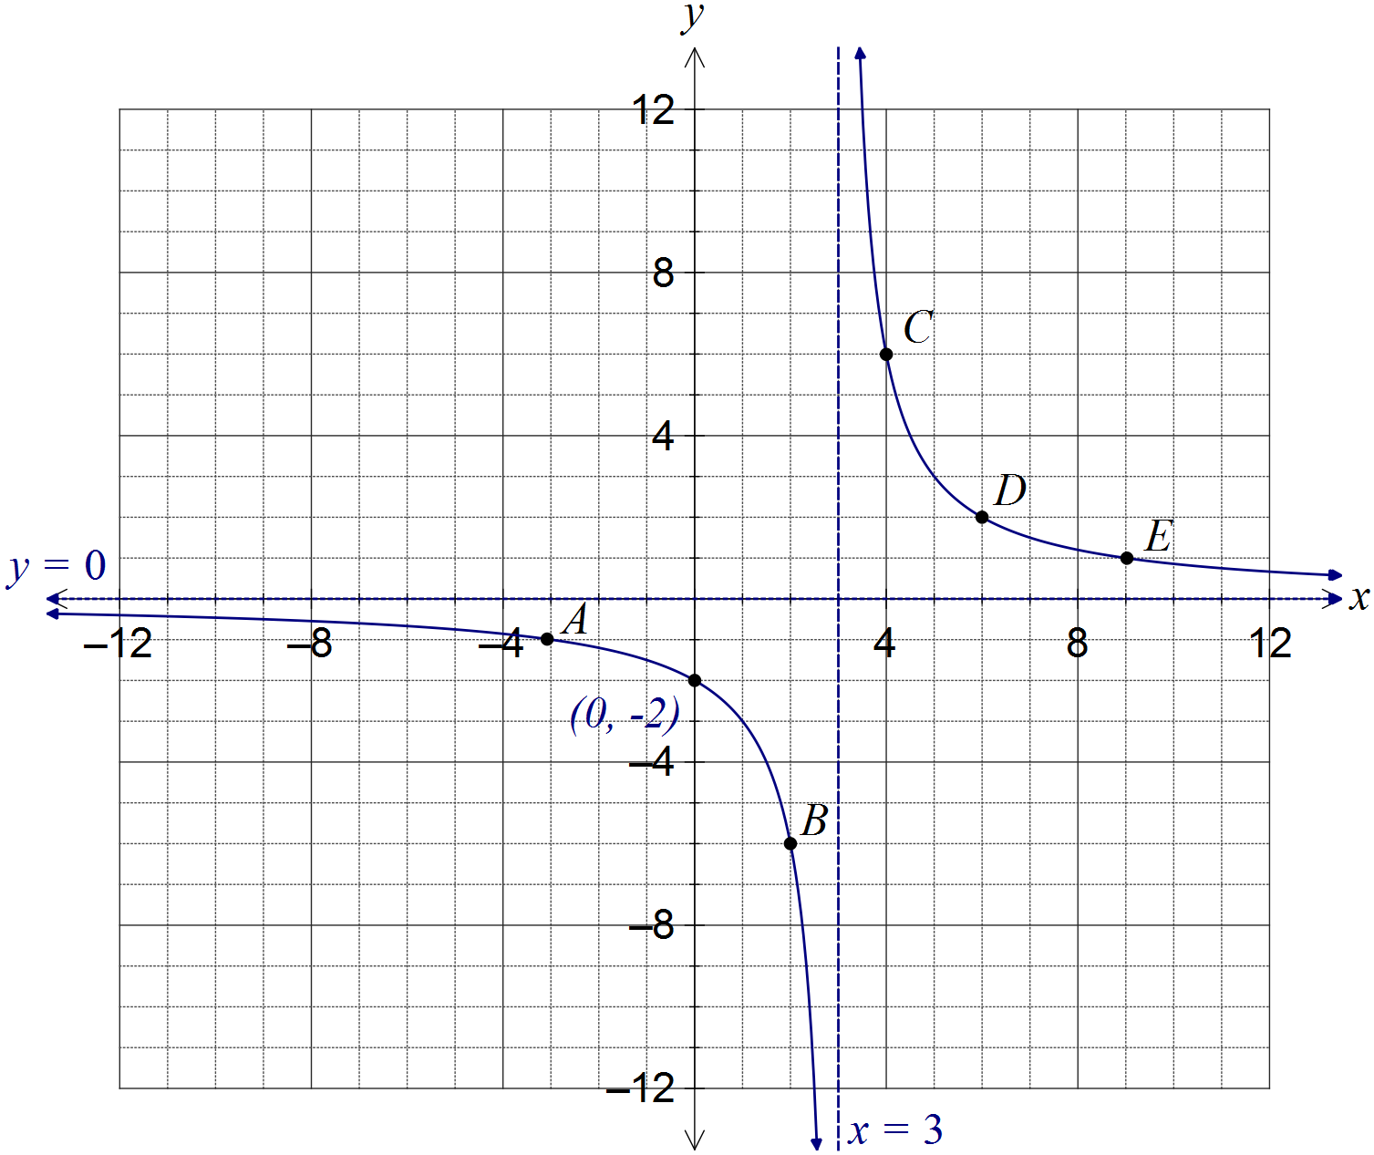

|  |
| --- |
| **Solution** |
| See graph |
| **Specific behaviours** |
| ✓ curves approach vertical asymptote, which is shown with equation  ✓ curves approach horizontal asymptote, without hooking upwards  ✓ coordinates of y-intercept shown  ✓ smooth curve passing through at least 3 of A, B, C, D or E |

(c) The graph of  is dilated vertically by a scale factor of 4 followed by a translation of three units to the right. Determine the coordinates of the y-intercept of the transformed graph. (2 marks)

|  |
| --- |
| **Solution** |
| Transforms the point (-3, -1) to (-3, -4) to (0, -4)  or |
| **Specific behaviours** |
| ✓ applies dilation  ✓ applies translation |

Question 12 (8 marks)

(a) A 3.6 m long ladder first rests against a vertical wall BC, making an angle of 70° with the horizontal ground. The ladder is rotated in a vertical plane about E to rest against wall AD, reaching a point 2.6 m above the ground.

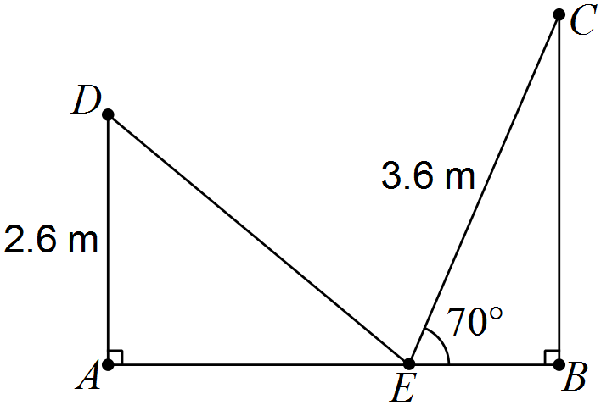

Showing use of trigonometry, determine

(i) the angle through which the ladder was rotated. (2 marks)

|  |
| --- |
| **Solution** |
|  |
| **Specific behaviours** |
| ✓ calculates angle in triangle  ✓ determines rotation angle |

(ii) the distance AB. (2 marks)

|  |
| --- |
| **Solution** |
|  |
| **Specific behaviours** |
| ✓ determines AE  ✓ determines EB and adds to get AB |

(iii) the distance DC. (2 marks)

|  |
| --- |
| **Solution** |
|  |
| **Specific behaviours** |
| ✓ uses cosine rule  ✓ determines length |

(b) A thin metal plate in the shape of an equilateral triangle has an area of 330 cm. Determine the side length of the triangle. (2 marks)

|  |
| --- |
| **Solution** |
| Let side length be x. Then |
| **Specific behaviours** |
| ✓ uses area formula  ✓ determines length |

Question 13 (9 marks)

(a) A square is inscribed in a circle of radius 16 cm, as shown below. Determine the area enclosed between the square and the circle. (3 marks)

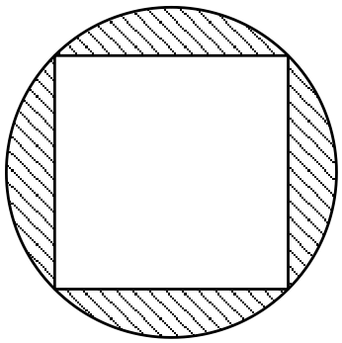

|  |
| --- |
| **Solution** |
|  |
| **Specific behaviours** |
| ✓ determines segment angle  ✓ determines one segment area  ✓ determines area of all segments |

(b) The perimeter of a sector, with central angle  radians in a circle of radius r, is 12 cm.

(i) Express  in terms of r. (2 marks)

|  |
| --- |
| **Solution** |
|  |
| **Specific behaviours** |
| ✓ substitutes into equation for perimeter  ✓ rearranges equation for |

(ii) Show that the area of the sector is . (2 marks)

|  |
| --- |
| **Solution** |
|  |
| **Specific behaviours** |
| ✓ substitutes r and  into area formula  ✓ expands and simplifies |

(iii) Determine the area of the sector if . (2 marks)

|  |
| --- |
| **Solution** |
|  |
| **Specific behaviours** |
| ✓ determines radius  ✓ calculates area |

Question 14 (7 marks)

A function and a relation have been graphed on the axes below.

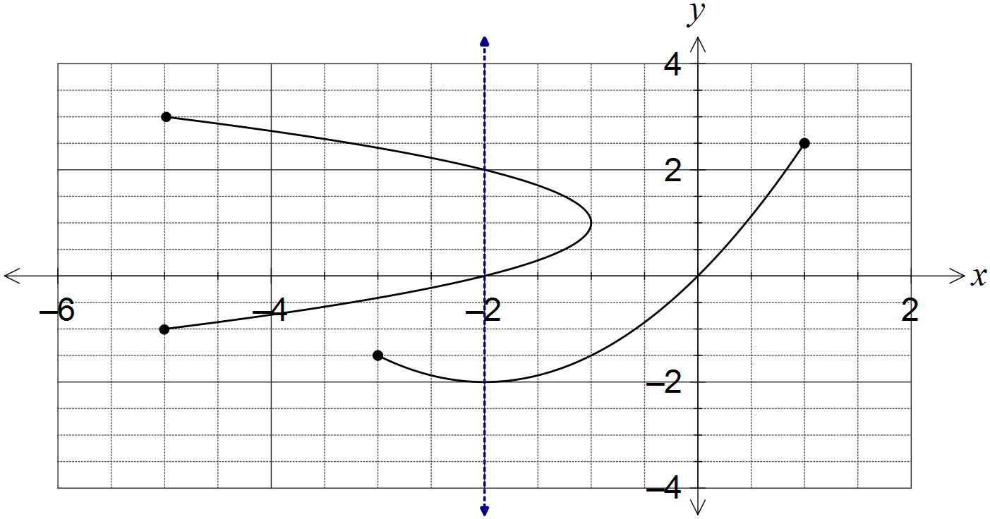

(a) Draw the line  on the graph and explain how it can be used to identify the relation. (2 marks)

|  |
| --- |
| **Solution** |
| See line on graph.  Vertical line cuts the relation more than once, but the function just once. |
| **Specific behaviours** |
| ✓ draws vertical line  ✓ explains vertical line test |

(b) State the domain and range of the function. (2 marks)

|  |
| --- |
| **Solution** |
|  |
| **Specific behaviours** |
| ✓ states domain  ✓ states range |

(c) The relation can be expressed in the form . Determine the values of the constants a and b. (3 marks)

|  |
| --- |
| **Solution** |
| When . |
| **Specific behaviours** |
| ✓ selects suitable point from relation  ✓ determines a  ✓ determines b |

Question 15 (9 marks)

A sensor was fitted to the tip of a blade on a wind turbine to measure the height, h metres, of the blade above the ground. The height was observed to vary according to the function  , where  is the time in seconds since measurements began.

(a) Determine the height of the blade tip above the ground when . (1 mark)

|  |
| --- |
| **Solution** |
|  |
| **Specific behaviours** |
| ✓ calculates height |

(b) Sketch the graph of  on the axes below for . (4 marks)

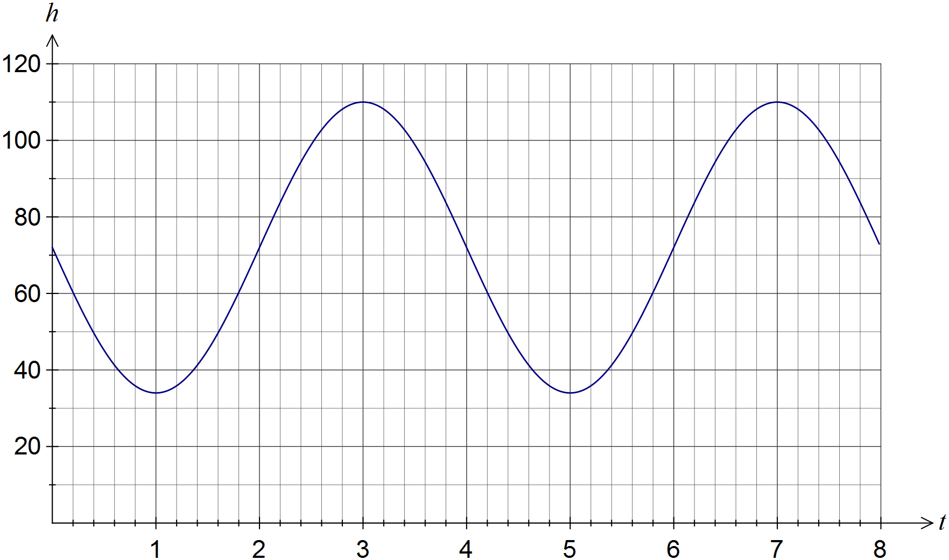

|  |
| --- |
| **Solution** |
| See graph |
| **Specific behaviours** |
| ✓  ✓ minimums at (1, 34) and (5, 34)  ✓ maximums at (3,110) and (7, 110)  ✓ smooth curve through above points, no abrupt 'corners' |

(c) How long does the blade take to rotate once? (1 mark)

|  |
| --- |
| **Solution** |
| 4 seconds |
| **Specific behaviours** |
| ✓ states time |

(d) Assuming the blade continues to rotate in this manner, determine the percentage of time during which the blade tip is at least 90 m above the ground. (3 marks)

|  |
| --- |
| **Solution** |
|  |
| **Specific behaviours** |
| ✓ solves for height of 90 m  ✓ determines interval above 90  ✓ determines percentage |

Question 16 (7 marks)

The graphs of ,  and  are shown below. Determine the values of the constants a, b, c, d, n, p and q.

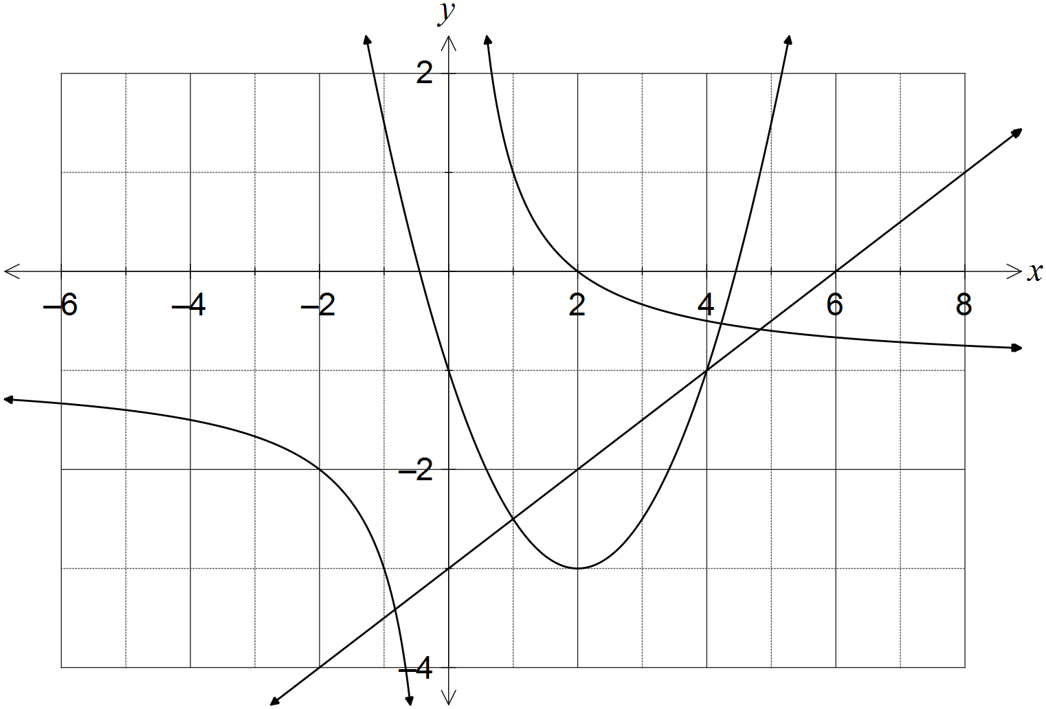

|  |
| --- |
| **Solution** |
|  |
| **Specific behaviours** |
| ✓ each correct value |

Question 17 (9 marks)

(a) The diagram below shows the five graphs , , ,  and , where a, b, c and d are constants.

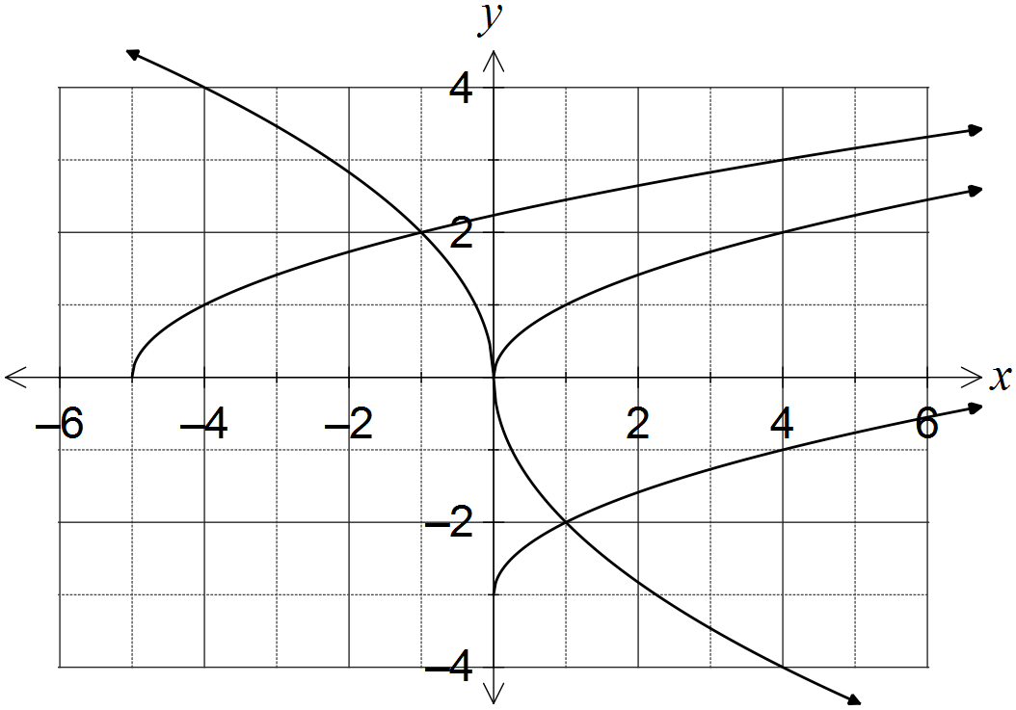

(i) Determine . (1 mark)

|  |
| --- |
| **Solution** |
|  |
| **Specific behaviours** |
| ✓ determines correct value |

(ii) Determine the values of the constants a, b, c and d. (4 marks)

|  |
| --- |
| **Solution** |
| a is vertical translation:  b is horizontal translation:  c is vertical dilation and reflection in x-axis:  d is horizontal dilation and reflection in y-axis: |
| **Specific behaviours** |
| ✓ determines a  ✓ determines b  ✓ determines c  ✓ determines d |

(b) Describe two transformations that will transform the graph of  to:

(i) . (2 marks)

|  |
| --- |
| **Solution** |
| Translate original graph 1 unit right and 2 units downwards (in either order) |
| **Specific behaviours** |
| ✓ horizontal translation  ✓ vertical translation |

(ii) . (2 marks)

|  |
| --- |
| **Solution** |
| Reflect in x-axis and dilate vertically by scale factor 5 (in either order) |
| **Specific behaviours** |
| ✓ reflection  ✓ dilation |

Question 18 (7 marks)

In triangle ABC, ,  cm and  cm.

Determine the largest possible area and smallest possible perimeter of this triangle.

|  |
| --- |
| **Solution** |
|  |
| **Specific behaviours** |
| ✓ uses sine rule to find acute angle for B  ✓ determines obtuse angle for B  ✓ calculates values of angle A  ✓ chooses largest value of A for maximum area  ✓ calculates area  ✓ chooses smallest value of A for minimum perimeter  ✓ calculates AB and states perimeter |

Question 19 (8 marks)

(a) Given that , where , show how to determine the exact value of

(i) . (2 marks)

|  |
| --- |
| **Solution** |
|  |
| **Specific behaviours** |
| ✓ uses right triangle to determine hypotenuse  ✓ states exact value |

(ii) . (2 marks)

|  |
| --- |
| **Solution** |
|  |
| **Specific behaviours** |
| ✓ considers sign of cos in 2nd quadrant  ✓ states exact value |

(iii) . (2 marks)

|  |
| --- |
| **Solution** |
|  |
| **Specific behaviours** |
| ✓ substitutes into double angle identity  ✓ simplifies correctly |

(b) Determine the two smallest solutions to the equation  for .

(2 marks)

|  |
| --- |
| **Solution** |
| Using CAS: , or: |
| **Specific behaviours** |
| ✓ determines one solution  ✓ determines both solutions |

Question 20 (7 marks)

(a) Determine the exact area of a sector enclosed by an arc of length 42 cm in a circle of radius 12 cm. (2 marks)

|  |
| --- |
| **Solution** |
|  |
| **Specific behaviours** |
| ✓ calculates angle  ✓ calculates exact area |

(b) In the diagram below, BC is a tangent to the circle with diameter AB and centre O.

Given that  cm and  cm, determine the shaded area. (5 marks)

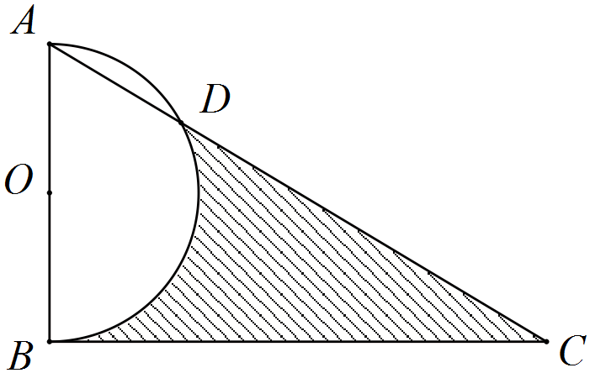

|  |
| --- |
| **Solution** |
|  |
| **Specific behaviours** |
| ✓ determines angle BAD  ✓ determines angle AOD  ✓ determines segment area  ✓ determines semicircle and triangle area  ✓ determines shaded area |

Additional working space

Question number: _________

Additional working space

Question number: _________

Additional working space

Question number: _________

Additional working space

Question number: _________

© 2016 WA Exam Papers. Rossmoyne Senior High School has a non-exclusive licence to copy and communicate this paper for non-commercial, educational use within the school. No other copying, communication or use is permitted without the express written permission of WA Exam Papers.